Upgrade eClient

## Option 1: Upgrade eClient from 8.4.02 to 8.4.03

Software:

* IBM II4C new version; (Bob will provide)
* EClient application package(the .ear file) the customized SIA version not the original eClient. (Bob will provide)

Steps:

* 1. Backup the :

livingstonCustom.properties

IDM.properties

IDMadminDefaults.properties

From:

D:\Program Files\IBM\WebSphere\AppServer\profiles\AppSrv01\installedApps\vQ9BeClientNode01Cell\eClient_WF.ear\eclient.war

* 1. You need to uninstall eClient ear file from websphere administration

Connect to : <http://localhost:9060/ibm/console/unsecureLogon.jsp> as admin and uninstall it from here :

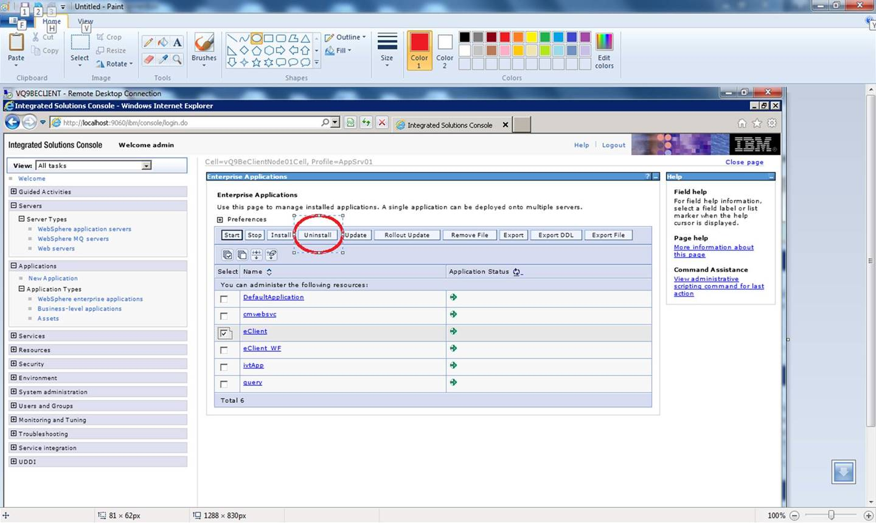

Or uninstall it from Control Panel Programs and Features.

* 1. Uninstall the II4C

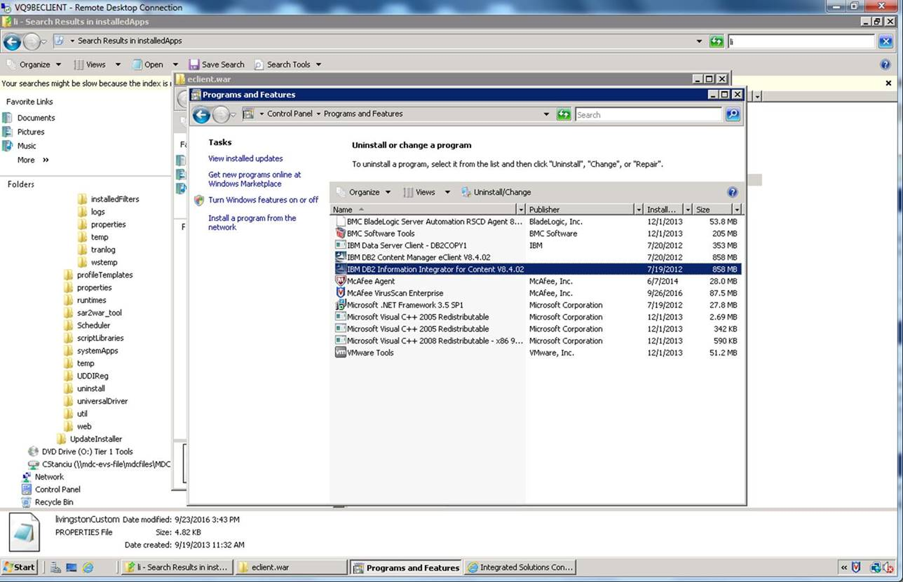

* 1. Install the new version for II4C
  2. Install the new eClient 8.4.3
  3. upgrade SIA eClient 8.4.3. from websphere administration



* 1. Copy the

livingstonCustom.properties

IDM.properties

IDMadminDefaults.properties

from the backup directory to the new location of eclient.

## Option 2: Upgrade eClient from 8.4.02 to 8.4.03

Software Link:

https://www-945.ibm.com/support/fixcentral/swg/selectFixes?parent=Enterprise%2BContent%2BManagement&product=ibm/Information+Management/Content+Manager+Enterprise+Edition&release=8.4.3.0&platform=AIX&function=all)

All upgrade Fix downloaded under:

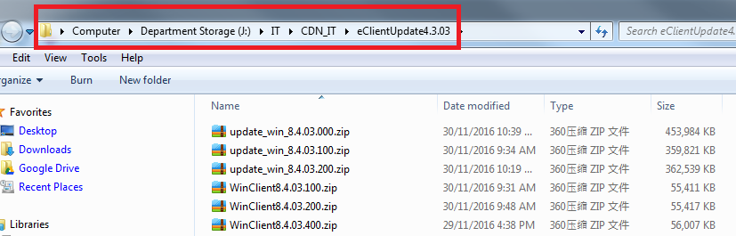

Steps:

1. Full and complete backup vq9beclient server
2. 2backup CM config files

livingstonCustom.properties

IDM.properties

IDMadminDefaults.properties

1. test the current eclient to confirm it is working and pointing to Lois
2. run update CM 8.4.3.0 to update ii4c/eclient
3. test it to confirm it is working
4. run update CM 8.4.3.4 to update ii4c/eclient
5. test it to confirm it is working
6. apply custom EAR file and config files
7. test it to confirm it is working

